**Machine Learning**

**Introduction**

Machine learning is an application of artificial intelligence (AI) that provides systems the ability to automatically learn and improve from experience without being explicitly programmed. Machine learning focuses on the development of computer programs that can access data and use it to learn for themselves.

The process of learning begins with observations or data, such as examples, direct experience, or instruction, in order to look for patterns in data and make better **decisions** in the future based on the examples that we provide. The primary aim is to allow the computers to learn automatically without human intervention or assistance and adjust actions accordingly.

**Q: What is Machine Learning?**A: It’s the science of getting computers to act by feeding them data so that they can learn a few tricks on their own, without being explicitly programmed to do so.

**Machine Learning**

**Techniques**

Classification and Regression are two major prediction techniques which are usually dealt with machine learning.

* **Classification** is the process of finding or discovering a model or function which helps in separating the data into multiple categorical classes
* **Regression** is the process of finding a model or function for distinguishing the data into continuous real values instead of using classes.

| **https://docs.google.com/uc?id=1Yl_tWJVHz7fUsTBbBOr81njw88ILQNKj** |
| --- |
| *Regression and classification* |

Machine learning algorithms are often categorized as supervised or unsupervised.

1. **Supervised machine learning algorithms** can apply what has been learned in the past to new data using **labeled** examples to predict future events.
2. **Unsupervised machine learning algorithms** are used when the information used to train is **neither classified nor labeled**.
3. **Reinforcement machine learning algorithms** is a learning method that interacts with its environment by producing actions and discovers **errors** or **rewards**.

**Deep Learning**

**Neural networks** are a set of algorithms, modeled loosely after the human brain, that is designed to recognize patterns. **Deep learning**, also known as **deep neural network**, is a machine learning technique that teaches computers to do what comes naturally to humans: learn by example. In deep learning, a computer model learns to perform classification tasks **directly** from images, text, or sound. It is the most popular and most used machine learning algorithm.

| **https://docs.google.com/uc?id=10ijd0akfHVnmXfr6u8TRX-EGuix988FQ** |
| --- |
| *Deep neural network* |

**Q: What is an artificial intelligence Neural Networks?**A: Artificial intelligence Neural Networks can model mathematically the way biological brain works, allowing the machine to think and learn the same way the humans do- making them capable of recognizing things like speech, objects and animals like we do.

**Q: What is Deep Learning?**A: Deep Learning is a subset of Machine Learning which is used to create an artificial multi-layer neural network. It has self-learning capabilities based on previous instances, and it provides high accuracy.

**AI Topics**

**Computer Vision**

**Computer vision** is a field of artificial intelligence (AI) that enables computers and systems to derive meaningful information from *digital images*, *videos* and other *visual inputs*.

There are many types of computer vision that are used in different ways. Some of them are:

* **Image segmentation** partitions an image into multiple regions or pieces to be examined separately.
* **Object detection** identifies a specific object in an image. Advanced object detection recognizes many objects in a single image: a football field, an offensive player, a defensive player, a ball and so on. These models use an X, Y coordinate to create a *bounding box* and identify everything inside the box.
* **Facial recognition** is an advanced type of object detection that not only recognizes a human face in an image but identifies a specific individual.
* **Edge detection** is a technique used to identify the outside edge of an object or landscape to better identify what is in the image.

| **https://docs.google.com/uc?id=1HnFgPVyMDO40s1OOBM9quOc2edfyzlcs** |
| --- |
| *Computer vision example* |

**Q: How is Computer Vision and AI related?**A: Computer Vision is a field of Artificial Intelligence that is used to obtain information from images or multi-dimensional data. [Machine Learning](https://lms.clarusway.com/mod/lesson/view.php?id=1053) algorithms such as K-means is used for Image Segmentation, Support Vector Machine is used for Image Classification and so on.  
Therefore Computer Vision makes use of AI technologies to solve complex problems such as Object Detection, Image Processing, etc.

**Natural Language Processing**

**Natural language processing (NLP)** is a branch of artificial intelligence that helps computers understand, interpret and manipulate human language. NLP draws from many disciplines, including computer science and computational linguistics, in its pursuit to fill the gap between human communication and computer understanding.

These underlying tasks are often used in higher-level NLP capabilities, such as:

* **Content categorization**: A linguistic-based document summary, including search and indexing, content alerts and duplication detection.
* **Topic discovery and modeling**: Accurately capture the meaning and themes in text collections, and apply advanced analytics to text, like optimization and forecasting.
* **Contextual extraction**: Automatically pull structured information from text-based sources.
* **Sentiment analysis**: Identifying the mood or subjective opinions within large amounts of text, including average sentiment and opinion mining.
* **Speech-to-text and text-to-speech conversion**: Transforming voice commands into written text, and vice versa.
* **Document summarization**: Automatically generating synopses of large bodies of text.
* **Machine translation**: Automatic translation of text or speech from one language to another.

| **https://docs.google.com/uc?id=1U4j45-r4nsJ9YSntp103zB0WtqzqAMI2** |
| --- |
| *NLP illustration* |

**Q: What is Natural Language Processing?**A: Natural Language Processing (NLP) refers to the Artificial Intelligence method that analyses natural human language to derive useful insights in order to solve problems.

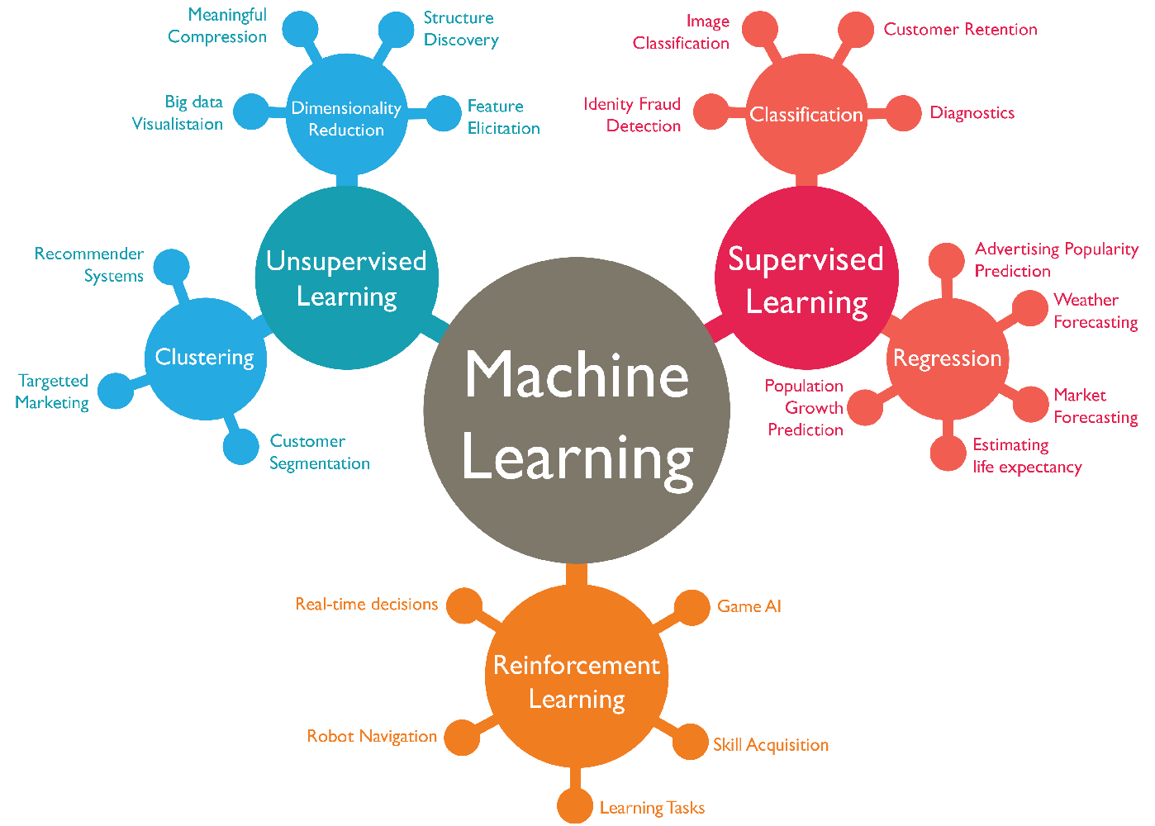

**Robotics**

Robots are artificial agents acting in real-world environments. Robots are systems in which many artificial intelligence and software components work together. **Robotics** is a branch of AI, which is composed of Electrical Engineering, Mechanical Engineering, and Computer Science for designing, construction, and application of robots.

The robotics has been instrumental in the various domains such as:

* **Industries**: Robots are used for handling material, cutting, welding, color coating, drilling, polishing, etc.
* **Military**: Autonomous robots can reach inaccessible and hazardous zones during the war.
* **Medicine**: The robots are capable of carrying out hundreds of clinical tests simultaneously, rehabilitating permanently disabled people, and performing complex surgeries such as brain tumors.
* **Exploration**: The robot rock climbers used for space exploration, submarine vehicles used for ocean exploration are to name a few.
* **Entertainment**: Disney’s engineers have created hundreds of robots for movie making.

| **https://docs.google.com/uc?id=1lmKHqwB_kcxr80C8p6Q9Nv6_yFdfyxCP** |
| --- |
| *Robots building Tesla car.* |

**Q: Explain the robotics domain of Artificial Intelligence.**A: Robotics is a subset of AI, which includes different branches and application of robots. These Robots are artificial agents acting in a real-world environment. An AI Robot works by manipulating the objects in it’s surrounding, by perceiving, moving and taking relevant actions.

|  |
| --- |
| *Machine learning algorithms* |

Q: What are the different types of Machine Learning?  
A: 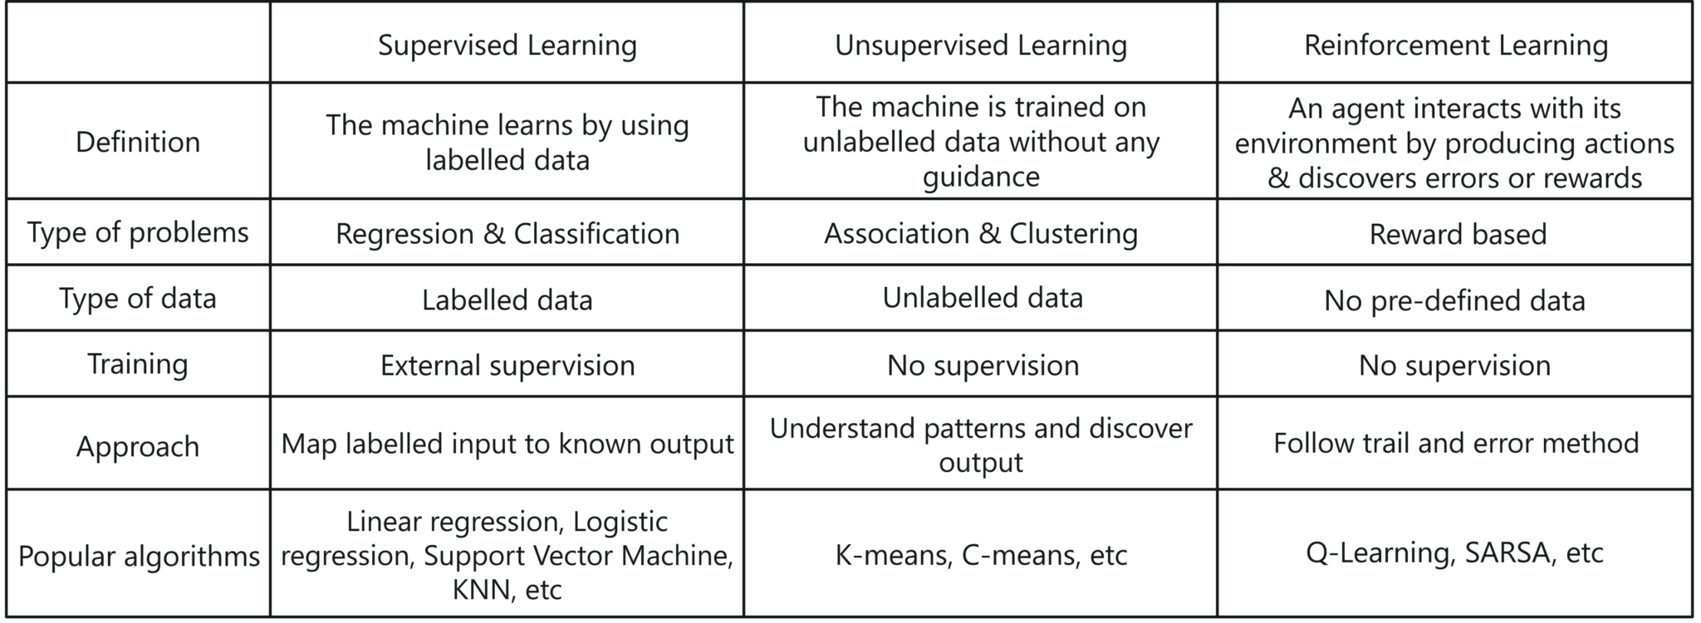

 - Interview Q&A

Q: Which is better for image classification? Supervised or unsupervised classification? Justify.  
A: **In supervised classification,** the images are manually fed and interpreted by the Machine Learning expert to create feature classes.  
**In unsupervised classification,** the Machine Learning software creates feature classes based on image pixel values.  
Therefore, it is better to choose supervised classification for image classification in terms of accuracy.